**CMPS 312 – Mobile Application Development Final Practical Exam – 6 December 2023 (duration 2h)**

**Objective:** Showcase your mobile development skills by crafting an Android application named “LitQuest” designed for book exploration.

**Task Overview:**

1. Sync the cmps312-lab repository and copy the Final Exam folder to your GitHub repo, which contains the base project named **LitQuest** with all the necessary dependencies.
2. Implement a **LitQuest** app that allows users to explore books by genres. Manage the app data in an SQLite database using Room Library.

# **Implementation Tasks:**

1. **Entity-Relations: [10]** Create two Entity classes with proper annotations named **Book** and **Genre** as shown in the figure 1. Ensure that the IDs are auto-assigned by the database. Add foreign key annotations with cascade delete and update on the appropriate entity.

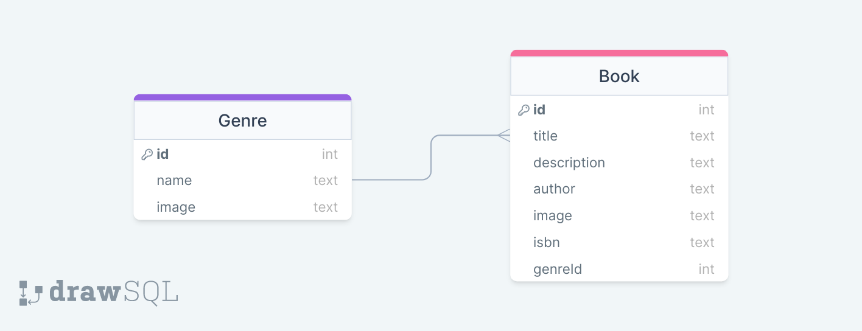

Figure 1 LitQuest ER Diagram

1. **LitQuestDao Interface and LitQuestDatabase [30]** Create the database class and the LitQuestDao Interface with necessary functions and annotations to allow users to:

* Get all books
* Add a new book
* Delete a book
* Update a Book
* Get a Book
* Add a new genre
* Get all genres
* Delete a genre and all associated books

1. **LitQuestRepository [10]** Implement the LitQuestRepository with all necessary methods listed above. Also, inside the repository, initialize the database if it is empty using the provided JSON files.
2. **LitQuestViewModel [20]** Create a LitQuestViewModel to serve as an intermediary between the UI and the repository. The ViewModel should:

* Manage the interaction between the UI and the repository for book and genre data.
* Provide Flows and Observable data to observe changes in the underlying data.
* Handle user inputs and interactions, ensuring proper validation and data integrity.

1. 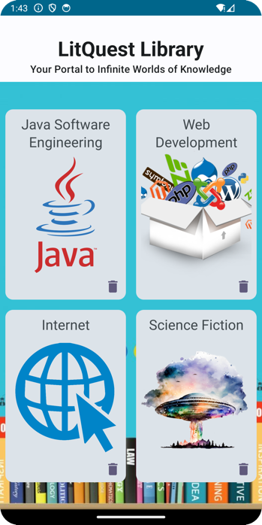**App UI and Navigation [30]** Implement the UI and navigation as described below:
   * **Initial Genre Display:** Upon launching the app, the interface should present a list of genres arranged in a Lazy Vertical Grid, similar to the illustration provided in the figure 2 below.
   * **Genre Deletion:** Users should have the capability to delete a specific genre and, in the process, remove all books linked to that genre.

Figure 2 Genre Screen



Figure 3 Book List Screen

* + **Genre Selection:** Users should be able to click on a genre from the displayed list. This action will lead them to the Book List Screen shown in figure 3, where they can explore a collection of books associated with the selected genre.
  + **Edit Button Functionality:** On the Book List Screen, an "Edit" button should be present. Clicking on this button will direct the user to the book editor screen, allowing them to modify book details.

Figure 4 Edit Screen

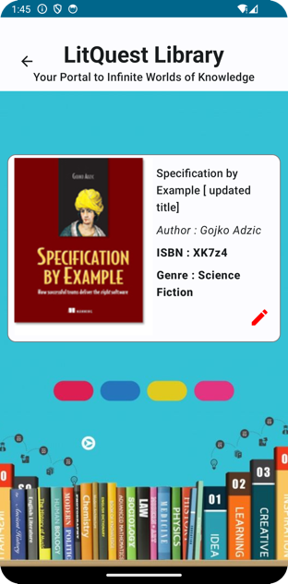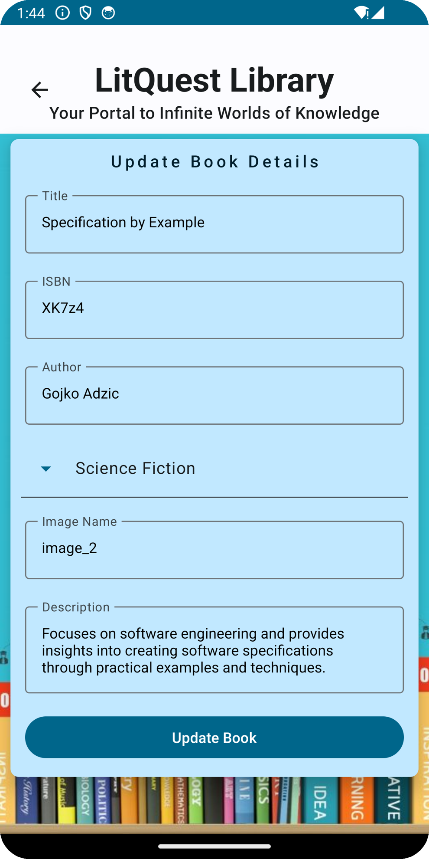

* + **Book Details Display:** Clicking on an individual book card within the book list screen should lead to the book details screen shown in figure 5, providing users with comprehensive information about the selected book.

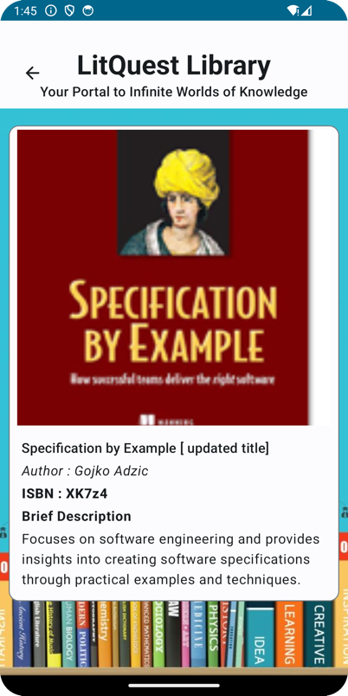

Figure 5 Details Screen